**CSC4350 Business Case Template**

Team Name: _______The Best Group______

Team Members: ____John, Rodrigo, Anahi__

Prepared For (Customer Name):_______Aurora University_____

Date: _______10/09/2019_________

Project Name: ___Inventory Management____

The business case should be from the perspective of the overall business that is requesting the product or service. It should consider several alternative solutions and recommend the best course of action for that business. In CSC4350’s case, this means you should consider either was is best for Aurora University or Kane County IT staff. You should assume that your solution will be developed, deployed and used for several years (at least 5). So that means, you need to address costs and maintenance process after you have graduated and left the university. For example, how can your recommendation be supported and how much with that cost?

In addition, you must present your results to class and the customer.

**CSC4350 Business Case**

1. **Executive Overview –** *Provide a summary of the opportunity and recommendation to management that gives them enough information to make a decision.* 
   1. *Describe briefly the problem/opportunity (what issue/need will resolve). What will be gained by this project from the customer/organizational perspective?*

*The Aurora University CSC and Nursing departments are currently tracking their inventory using pen and paper in the nursing department, and a free, online tool for the CSC department. (what outdated software? We are not tracking it at all) This software we will produce will greatly improve the tracking and modifying of inventory items within their respective departments. This project will save the departments, and in turn the school, hundreds to thousands of hours of time that is currently being spent on verifying inventory stock and modifying the current list of items.(Ok the paper better back up the above claim)*

* 1. *Specific solution and rationale for selecting it (especially business rationale) . In particular, why this solution over any other. How does your solution compare to the other alternatives?*

*This solution makes the most sense from all aspects of a business case. Financially, it will save the school money by reducing time and wasted materials, such as nursing supplies, missing computer parts, or possible item misplacements. This solution will also increase accountability for students to return school items. (What is product waste?) This solution also provides great learning and experience for the students that would not be possible by purchasing outside software. It also will improve security as everything was designed “in house”. This is a benefit to the security of the system as all software and database information will need to be implemented with supervision from the school. The inventory system and any linked sites will only operate within the school’s server system. There will be no possible access to this inventory system from outside of the school’s network. Why does that improve security?)*

* 1. *What is the bottom-line cost and benefit of selecting this solution? That is how much will it cost and what specific benefits will this solution provide?*

*The bottom-line is that the overall cost of this product being produced by a student team is that there will be no additional development costs. All costs are included in the salary of the professor of the current class producing the software, as well as any costs included with allowing students to attend this class. This solution provides the school, as well as the students major benefits overall. There is a possibility the school will need to provide additional hardware for a reasonable cost.*

*It is assumed later in this business case that the server cost will be included in any future budget related to the inventory management or the Nursing or Computer Science departments. The scanners currently being used in the Nursing department cost approximately $75 on Amazon, it is our recommendation that Aurora University purchase similar scanners to those currently in use. We recommend that the school purchase two (2) additional scanners to be implemented within the CSC department. There are no additional maintenance costs other than the costs that are included within the staff salary budget. This brings a total cost for this project to ~$150, plus the server space cost.*

*In regards to any maintenance, it is assumed later in this business case that future students and CSC professors will be capable of addressing any bugs or additions. There will not be any additional costs for this.*

*The server it needs to run on is a cost. Are you going to use scanners? Those cost money too. Is there maintenance? Who will pay for that?*

* 1. *What are the major risks in this project from the overall business standpoint and how to do plan to overcome them?*

*The biggest risk is that this software will not be implemented or maintained properly, ensuring that hardware will eventually fail, and that the system will be taken offline.*

*The best way we plan to ensure the quality and uptime of our inventory system is by extensive documentation regarding the process involved in creating and setting up the system. The current plan is for all code to include detailed comments describing the system and how it functions. We will also include a report that describes the process to shut down, update, and reboot the website to ensure proper maintenance in the future.*

*The risks involved with completing the project on time and delivering all requested features have all been identified. To help mitigate the potential risks, this project will be taken into the future capstone classes offered at Aurora University. This will allow additional time for development.*

*That is a big risk. How will you mitigate that risk? You also have a risk that your team will actually complete the project on time with all the features needed. T*

1. **Key Objectives –** *Keep track of items used for nursing and CSC departments. Ensure items can be scanned in and out of the system consistently. Provide a security layer against prying eyes.*

**Provide a secure login page for the database, which will prevent unauthorized access to the inventory system. Access will not be granted until the proper credentials have been entered.**

1. *(what does that mean?)*
2. **Business Context –** *The current environment is not very well documented. Currently, the professor will keep a general count of the inventory and what items are present. The only items currently being tracked continuously are the medications. (ok)*
3. **The Business process will not change at all.** *The only difference will be the students or professors will now scan out items when taking them out of inventory.you need to describe this diagram. For example, why is assign work a decision box? What is* **remove items from**and why is it a decision box? Why is stock a decision box? Where the stop and end state of this diagram? This diagram and its description needs work. Also this only describes the nursing department what about CSC?

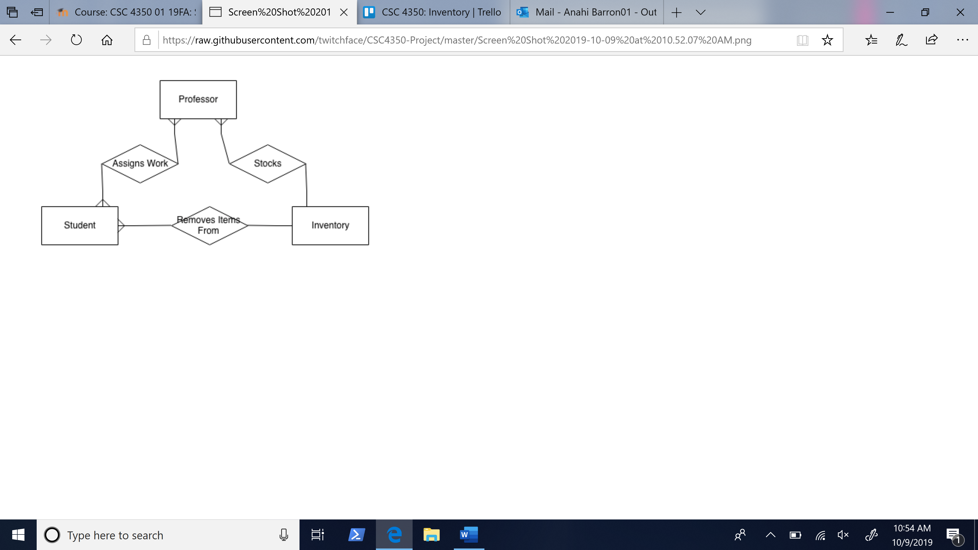

**Opportunities that this will address –**

1. *The biggest capability of this inventory management tool is that will allow the expansion of tracking inventory items in a more accurate way.*
2. ***How is this a revenue creation OR a cost reduction case?*** *This is a cost reduction case because by scanning the majority of items in and out of the system it will reduce waste and redundancy. The initial projected cost of this project is $150 and by comparing that to the time spent by professors and students searching and maintaining the inventory system, it is clear this will be a cost saving process. With the reduction in lost materials it is clear that this system will reduce costs for the school. Assuming double the initial cost, bringing it to $300, we estimate over $300 worth of materials will be saved per year. E.g. 1 lost Raspberry Pi costs the school $30, a lost box of needles costs the school $10, and any major equipment that is lost will likely cost upwards of $100 a piece. It is clear from a basic estimation of risk that this system will only save money in the foreseeable future.(Need to explain since needs server time and Scanner costs and possibly maintenance costs.*
3. ***If this is an innovation case, describe the transformative sources of competitive advantage?*** *Even though this is not an innovative idea the process will help increase the quality of the nursing department at AU*
4. ***When this project is complete, what new capabilities will you provide that will help the business?*** *As I stated before the larges benefit of this project will be the time saved and potential financial savings, the only new capability will be the professor’s ability to print out inventory reports and detailed reviews of how many materials were used.*
5. **Critical Success Factors -** *List key things must happen to be successful. This might include specific criteria, sponsorship or other resources needed. For example,* 
   1. *Items must be able scanned in an out with a 99.99999 % accuracy, any items that will not scan properly will need to be manually inserted into the system. – so you plan to fail 1 out of 100 times? Sounds high.*
   2. *We will need permanent server space in the aurora university server site. This only includes digital space on the server’s storage drive, as there are no physical spatial requirements for this project that don’t include the scanners.– Physical space? Or space for the web app? I don’t know what that means.*
   3. *Need to be able to print labels that match the scanning system OK*
   4. *Needs to be only accessible by the nursing department personal.*

1. **Recommended Solution and Solution Details –***Provide an overview of the recommended solution and then specific details about the solution*

* *E.g., We will develop a custom-made solution using mysql, ruby on rails with a custom bootstrap front-end. The solution will completely automate the sales bid process from front to start. We expect this development to require 25 weeks with 5 full time developers.*
* *We will develop a custom-made solution web app using SQL, and JavaScript, ReactJS. That runs on what? With scanners?*
* *The solution could completely reduce human error and help keep more accurate inventory with this system. But it fails 1 out of 100 times?*
* *We expect this development to require 10 weeks for our prototype with 3 full time student developers. After the prototype is completed, the development cycle will take approximately 16 weeks, concluding with a final presentation in May. Thats all? No development?*

1. **Alternative Solutions and Solution Details –***Provide an overview of the various solutions, describe the solution and provide specific rationale for not selecting it. Provide at least 3 alternatives solutions (beyond the one your recommend), research them, and describe, their advantages and disadvantages and recommendation for that solution. That is, provide a specific reason why you either recommend or not recommend the solution. In addition, summarize this analysis in the following table:*

**This section lacks research.** *You need to research alternatives. There are several out there. Without that, you cannot make any statements that you solution is better or even just as good as the off-the-shelf product. This is largely missing from this analysis*

*Some popular alternatives inventory management systems the school can use are:*

*QuickBooks Enterprise, with an annual cost of $1848.00*

*Zoho Inventory Pro, annual cost of $2,988.00*

*CIN7, annual cost of $3,588.00*

*These alternatives have an advantage on the accounting side as they can allow for finance information and reports. These are functions that the school departments are not going to take full advantage of, but yet still have to pay a high cost for features that won’t be put to use.*

*Most existing software has a high starting cost and while it could be used as a solution to manage inventory, it is not specific to the inventory needs of Aurora University. Our inventory system will be developed supervised to meet the requirement of our departments; it is being designed as a custom solution to our department’s inventory needs. By looking at the above sample costs, our solution has a much lower cost to Aurora University.*

|  |  |  |
| --- | --- | --- |
| *Alternative* | *Description* | *Specific Reason Rejected* |
| *Don’t modify the process* | *Leave process as is currently with paperwork* | *It’s a poor system, not solution school needs* |
| *Buy new fully developed software* | *Research and purchase a prebuilt inventory system* | *Many are too overpriced for the basic needs for the school* |
| *Hire inventory personnel* | *Hire a full-time employee to specifically monitor the inventory around school* | *Extremely expensive to pay an employee for current inventory needs.* |

1. **Cost and Benefits** *– Describe the project’s expected costs and return on investment Cannot do this section with the previously needed research*

*Costs*

|  |  |  |  |
| --- | --- | --- | --- |
| **Project Costs** | **Details** | **Frequency** | **Amount** |
| **Staffing** | N/A | N/A | N/A |
| **Software** | N/A | N/A | N/A |
| **Maintenance** | 1 maintenance student or professor | Once per semester, or once per year | Free, assuming in house staff |
| **Hardware** | Scanner purchases | Possibly replace a single scanner each year | $75/year |
| **3 year projected totals** | 3 - 6 students/professors over 3 years | N/A | $225/year |

*Benefits Cannot do this section with the previously needed research*

|  |  |  |  |
| --- | --- | --- | --- |
| **Cost Reductions** | **Details** | **Frequency** | **Amount** |
| **Staffing reductions** | Will reduce need for multiple inventory checks by staff | Should reduce inventory checks by twice as much | Possibly end up reducing Nursing department staff |
| **Hardware reductions** | N/A | N/A | N/A |
| **Time saved** | Huge amounts of time saved using software instead of pen and paper | Time will be saved every single day | Will add up to hours and possibly days of saved time over a year |
| **Other** | N/A | N/A | N/A |
| **3 year projected totals** | Tons of time saved | Every day time should be saved | Hundreds to Thousands of hours of time saved |

*Anticipated Savings over 3 years Cannot do this section with the previously needed research*

|  |  |
| --- | --- |
| **Benefits** | **Details** |
| **More control over items** | Items should be tracked much more efficiently leaky |
| **Security** | Will reduce chances of information going rogue |
| **Maintenance savings** | Maintenance costs will increase unfortunately |
| **Other** | Staff time will be better spent in other areas |

1. **Assumptions** *– List any assumptions for the solution. In particular include:*
   1. *We assume the school will buy any necessary equipment (scanners). good*
   2. *We assume the Nursing Department will properly label all inventory items. We assume the CSC department will input the proper serial numbers? Bad assumption. We will not label.*
   3. *We assume the school will provide us with the list of inventory they need to keep track of.*
   4. *We assume this system will be used for at least 3 years, and will need to be maintained by the IT department. It is also possible that future CSC professors and interns will maintain this system using the robust documentation left by our group. What CSC department? You need more thought on this point.*

*Be specific E.g., We will use the system for at least 5 years. We will need to hire an intern for 6 months a $20 /hour*

1. **Deliverables –** *what are the intermediate and final products that you will produce. This includes models, documents, prototypes and final product versions*
2. **Need much more deliverables.** *Why do you stop at a prototype? Design models and UI prototypes should be invluded. You need to do > 1 of these*

|  |  |  |  |
| --- | --- | --- | --- |
| ***ID*** | ***Item*** | ***Dependencies*** | ***Timeframe*** |
| *1* | *Process model complete and a mockup/sketch finished* | *Meetings with customer & team* | *10/17/19* |
| *2* | *Design Database table diagrams* | *Receiving all inventory needed* | *10/24/19* |
| *3* | *Version 1 prototype* | *Deliverables 1 & 2* | *12/09/19* |

1. **Final Recommendations –** *Specific conclusions and management recommendations. You will need to justify your recommendations. Why specifically are you making these recommendations. For example, the following is clear but does not specify why. It does nothing to convince management.*

*“We recommend that we begin this development using 3 developers for 4 months. If any assumptions prove false, we may need to reevaluate this business case. “*

*We recommend that we begin development using 3 junior developers for 10 weeks. If any of the assumptions we have written prove to be false, this business case will need to be reevaluated to determine a modified course of action and a new way to proceed forward, if at all.*

*The cost and time of implementing a fully developed and purchasable inventory management system vastly outweighs the benefits of building a system using the computer science department and the free labor provided by student development. Any inventory management system that is purchased and implemented from outside of Aurora University will have a large learning curve and need to be learned by more than just the immediate staff using the product to ensure safety and security.*